# Release Information

|  |  |
| --- | --- |
| *Release* | *2* |
| *Leader* | *Liam* |
| *Git Repository* | *https://crainl@atlas.ion.uwplatt.edu/bitbucket/scm/ise/1-nullreferenceexception.git* |

Give a one to two sentence description of new functionality provided by this release.

# Progress

|  |  |  |  |
| --- | --- | --- | --- |
| **Stories and spike solutions worked on during this release** | | | |
| **Story, Spike** | **Description** | **% Impl.** | **Notes, plan for completion** |
| *NRE-6* | *Be able to login to the system so that a user can use their registered user account* | *100* |  |
| *NRE-18* | *Be able to view a list of other users currently using the service* | *100* | *Updates on disconnection of user* |
| *NRE-19* | *Be able to register as a user in order to use the service* | *100* |  |
| *NRE-23* | *Be able to safely shut down the server as an administrator in order to not lose user data* | *100* | *Necessary for current implementation but won’t be on deployment* |
| *NRE-39* | *Be able to send a message by pressing the enter key on the keyboard* | *100* | *Added functionality for enter using alt-enter in message box* |

|  |  |  |
| --- | --- | --- |
| **Accomplishments by engineer** | | |
| **Team Member** | **Total Time (hrs)** | **Stories, Spikes implemented** |
| *Liam* | *15.5* | *NRE-54 (w/ Mitch)*  *NRE-55 (w/ Mitch)*  *NRE-57 (w/ Mitch)* |
| *Mitch* |  | *NRE-52 (w/ Liam)*  *NRE-53 (w/ Liam)*  *NRE-58 (w/ Liam)* |
| *Austin* |  | *NRE-40*  *NRE-43*  *NRE-44*  *NRE-46*  *NRE-51* |
| *Ryan* |  | *NRE-41*  *NRE-42*  *NRE-45*  *NRE-47*  *NRE-50* |
| TEAM TOTAL |  |  |

|  |  |
| --- | --- |
| **Document updates** | |
| **Document** | **Changes** |
| *README.me* | *Adding additional steps for new dependencies* |
|  |  |

# Issues

Document anything that is not decided yet and needs to be resolved at some point.

|  |  |  |  |  |
| --- | --- | --- | --- | --- |
| **Issue Number** | **Discovery**  **Date** | **Resolution**  **Date (Est.–Act.)** | **Responsible Person** | **Description (Prob / Resolution)** |
| 1 | 04/04/19 | 04/04/19 | Ryan | When a user was already connected and someone tried to log in as that user the client would receive the hashed password in the message display area. Solved by checking if a client was already connected on login button push. |
|  |  |  |  |  |
|  |  |  |  |  |
|  |  |  |  |  |

# Screen Shots

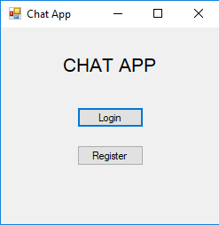

*On launch the screen a user is taken to.*

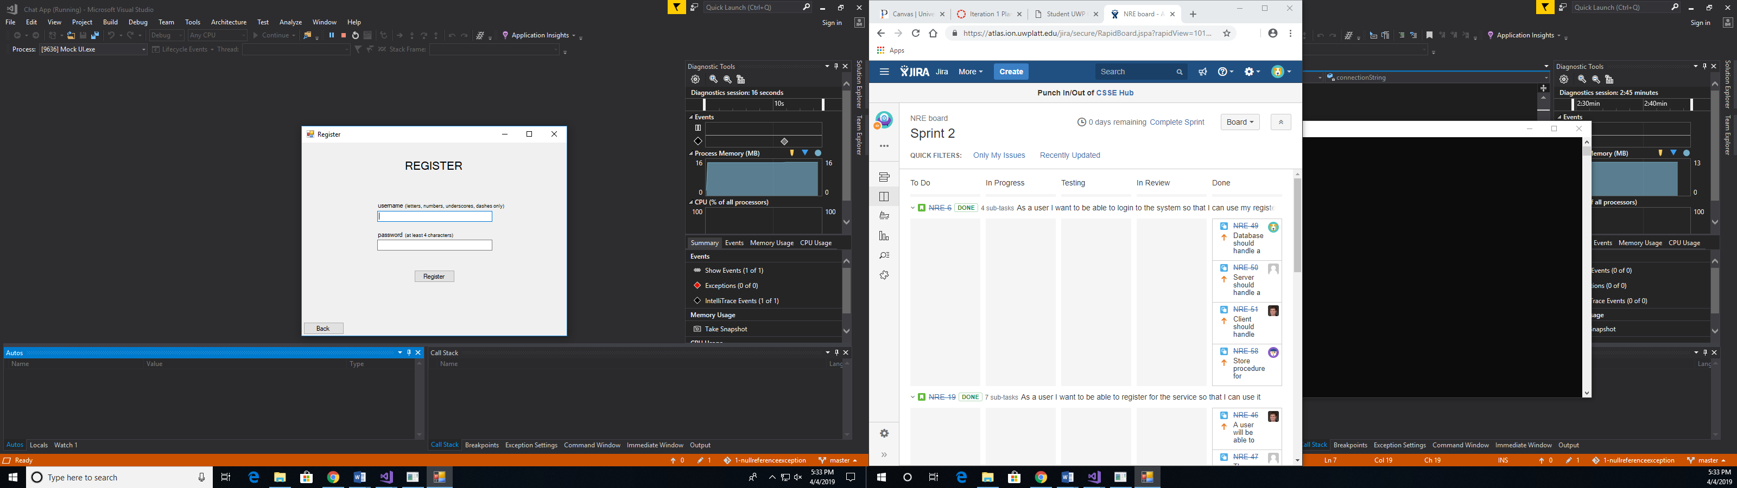

*The register user screen where a new user is taken when the press the Register button on the launch screen.*

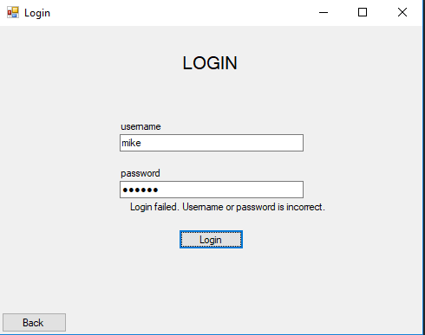

*If a user fails to log in a message pops up informing the user that the username or password were incorrect and allows them to attempt to login again.*

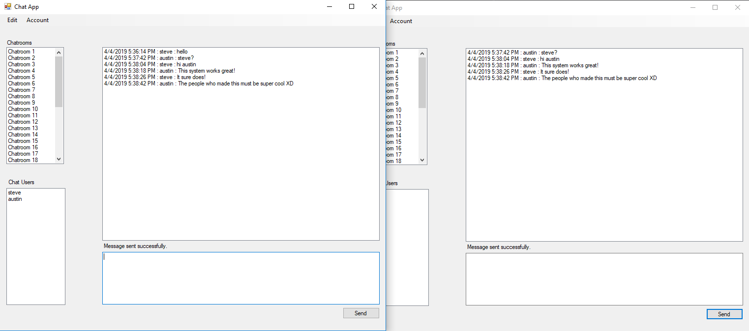

*The messaging service remains the same from the last iteration where the users can connect and send each other messages using the chat room. An addition is the chat user list which displays the users currently on the messaging service.*